**9th August, 2019.**

**Report 1.**

Link to the dataset used: <https://www.kaggle.com/datamunge/sign-language-mnist>

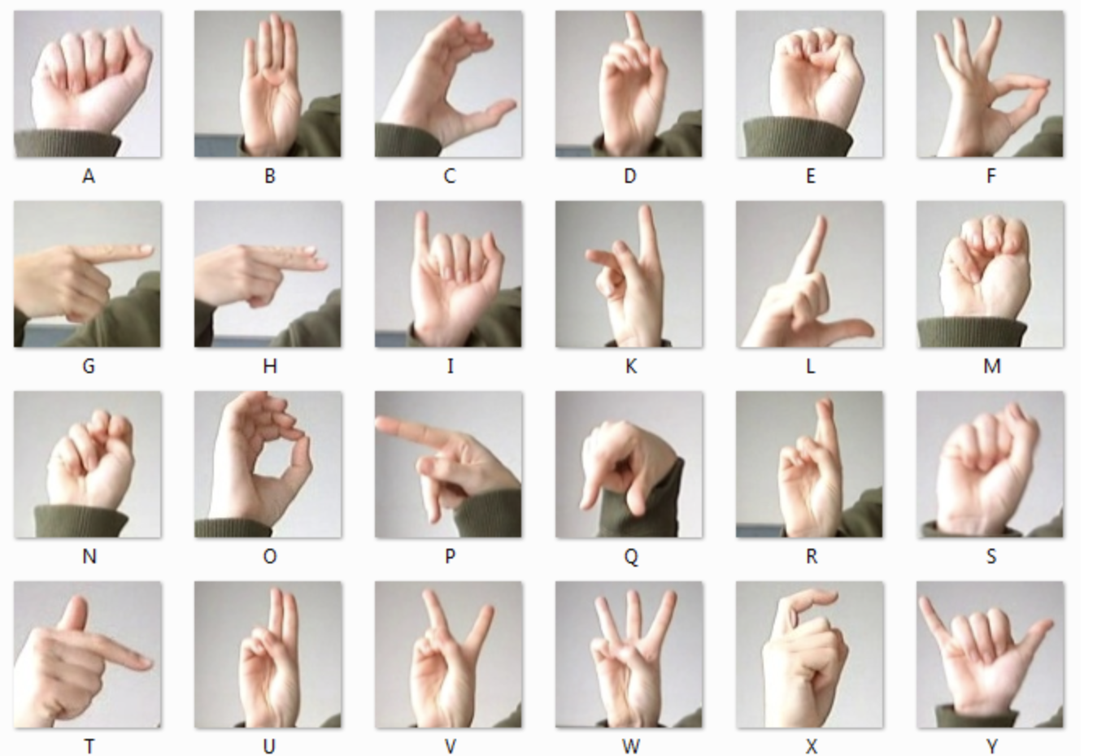

The data was given in the form of pixel values. There were a total of 27454 images over 24 classes of alphabets. This was the data for Sign Language MNIST.

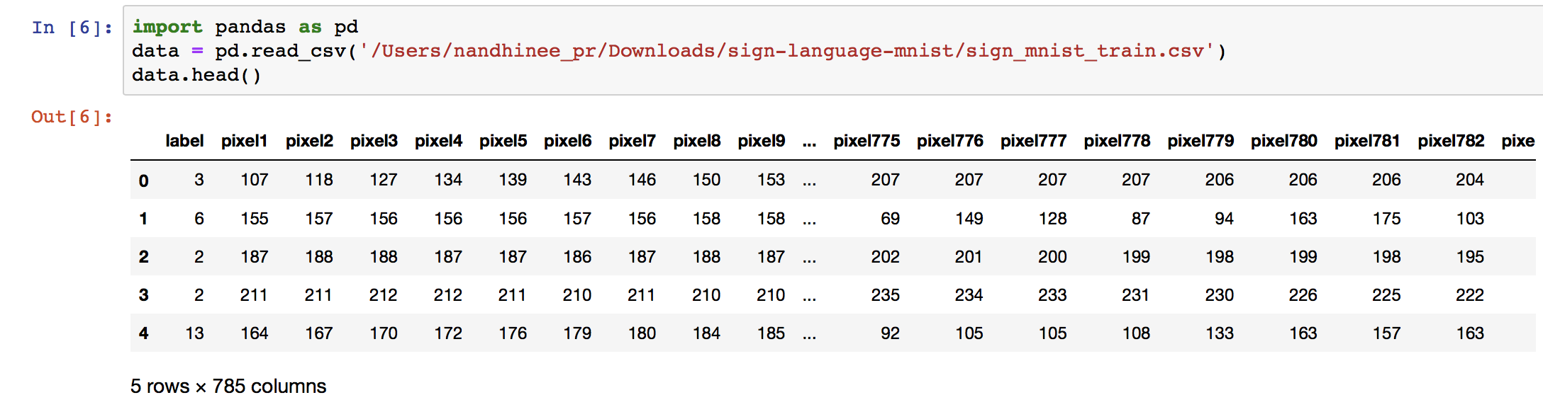

We wrote a script to construct image data from the pixel values given.

This script was run for all the 27454 images.

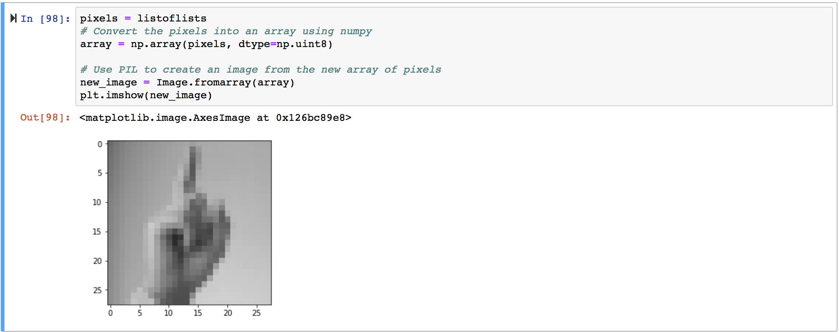

Later, we segregated the images according to their class labels.

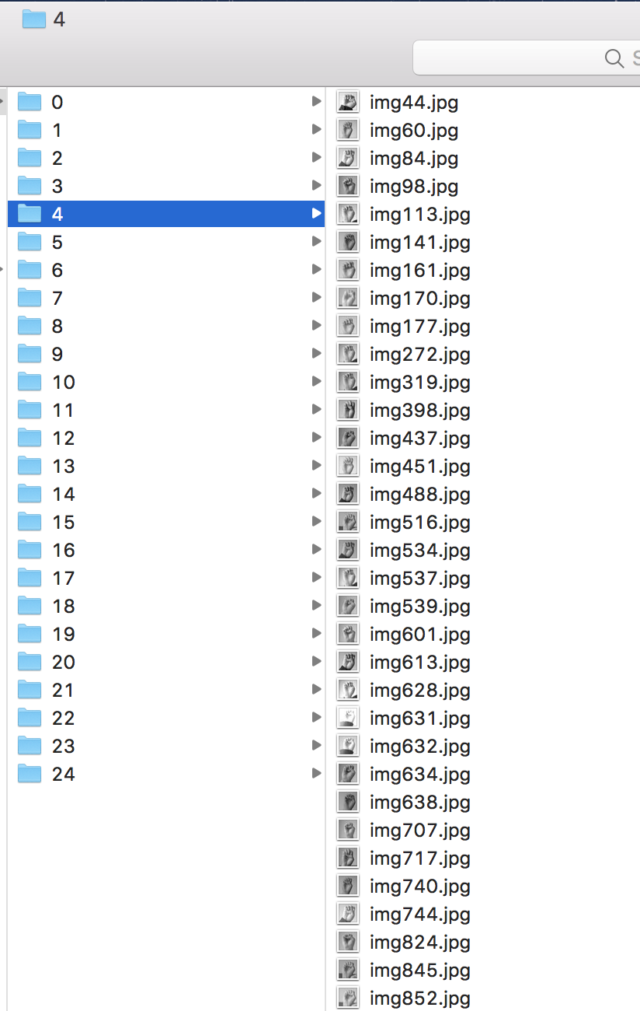

We’ve prepared the data. We will keep you updated with our with model building.